7] Big Data Fundamentals with PySpark (M2 Programming in PySpark RDD’s )

Advanced RDD Actions (M2 -> SM4)

1) Download RAR on STAGING_AREA

2) Extract the RAR

3) Put the *.ipynb files in UBUNTU_HOME/test-jupyter/P2/M2/sm4

4) Import the notes in Jupyter Notebook

5) Follow the instructions and give the solutions

* Code/Dataset

data/4_AdvancedRddActions.rar

TimeLine = 30 Minutes

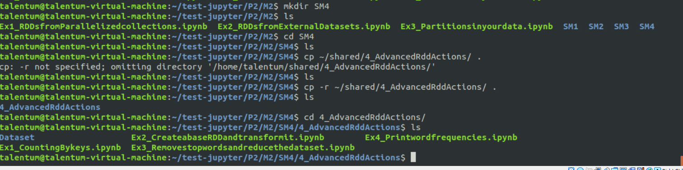

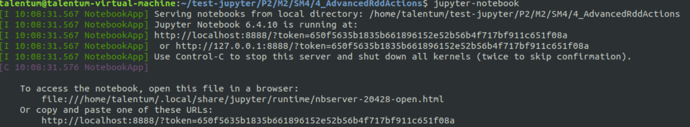

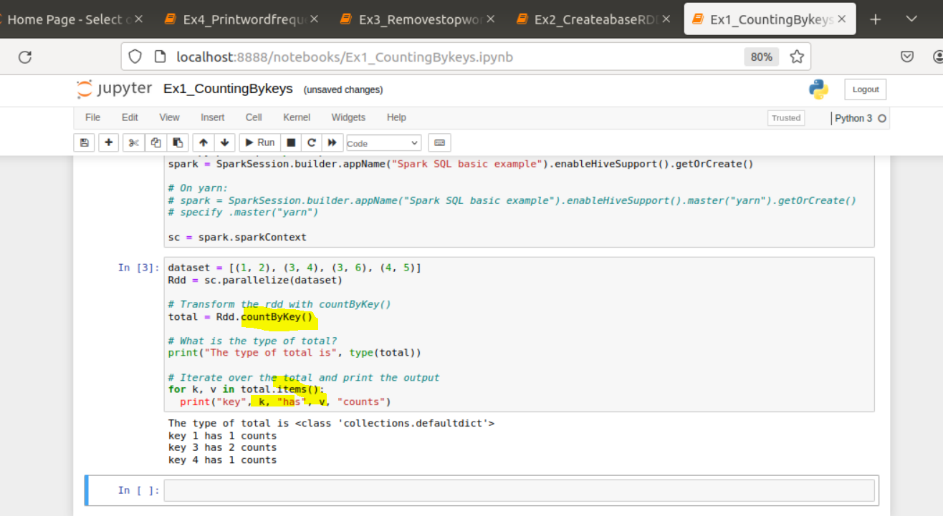

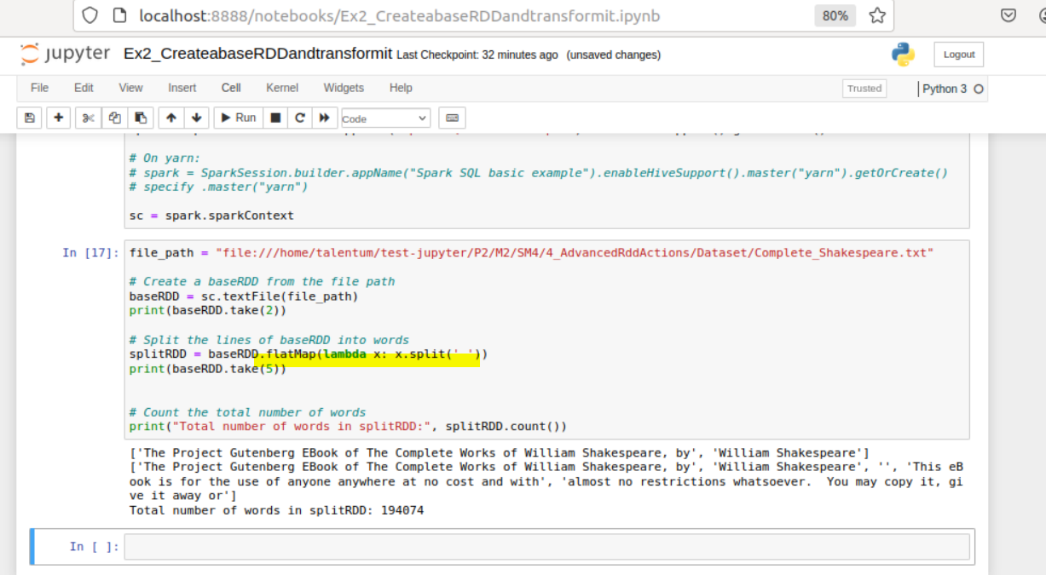

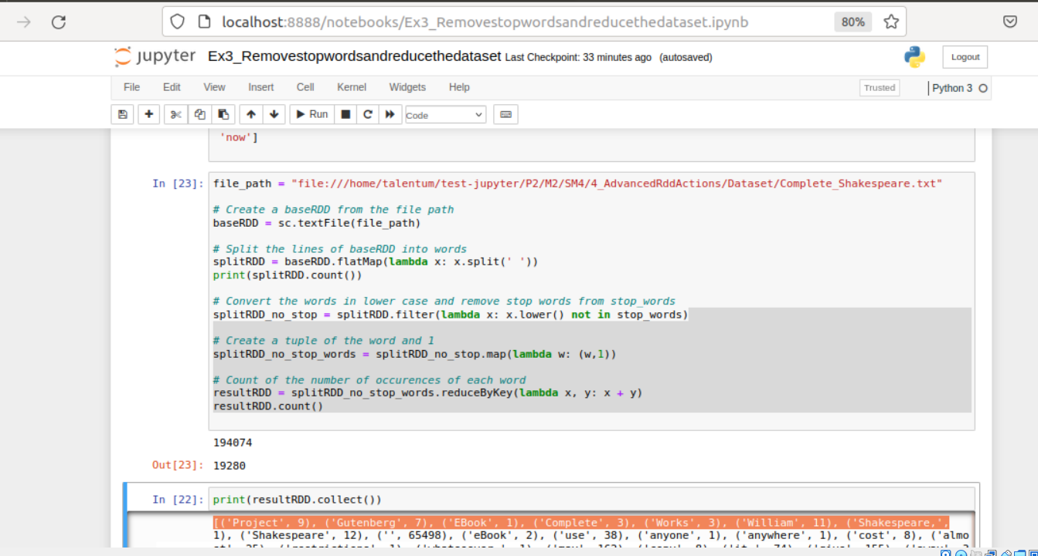

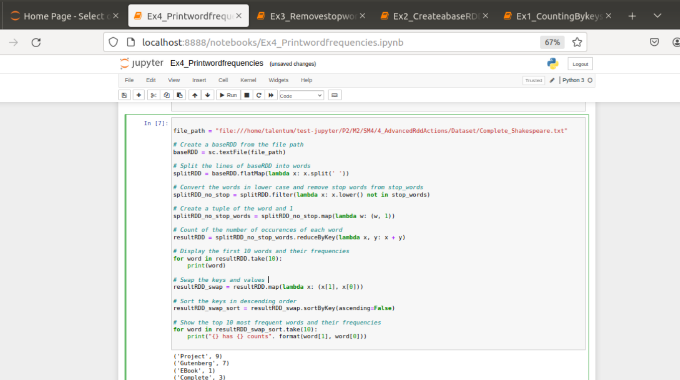

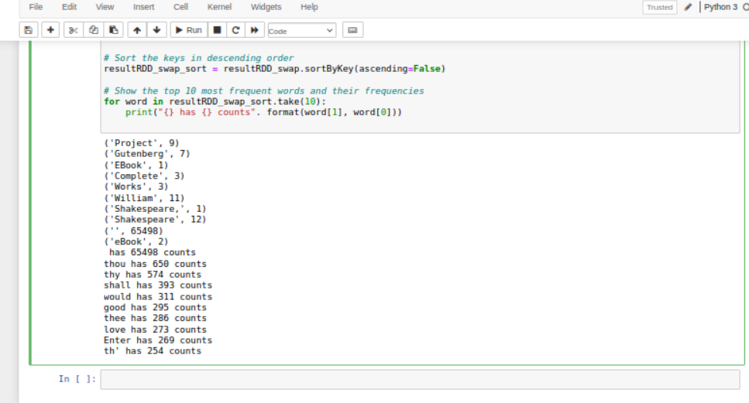

LAB

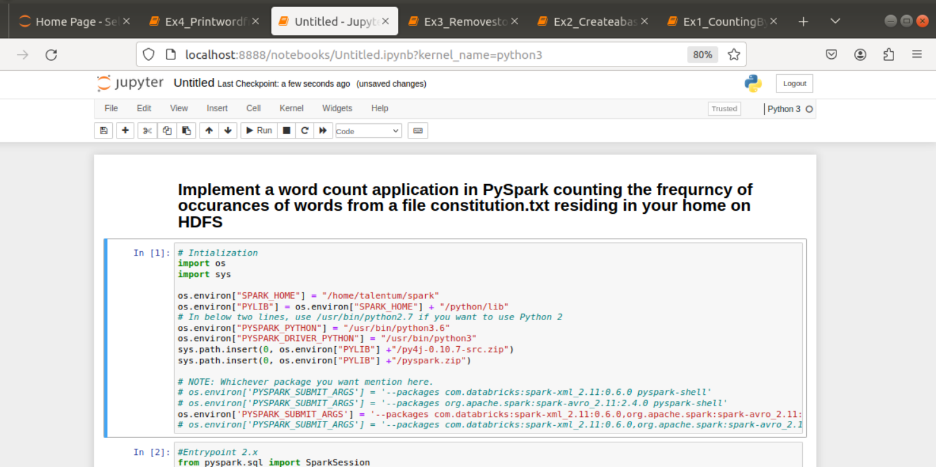

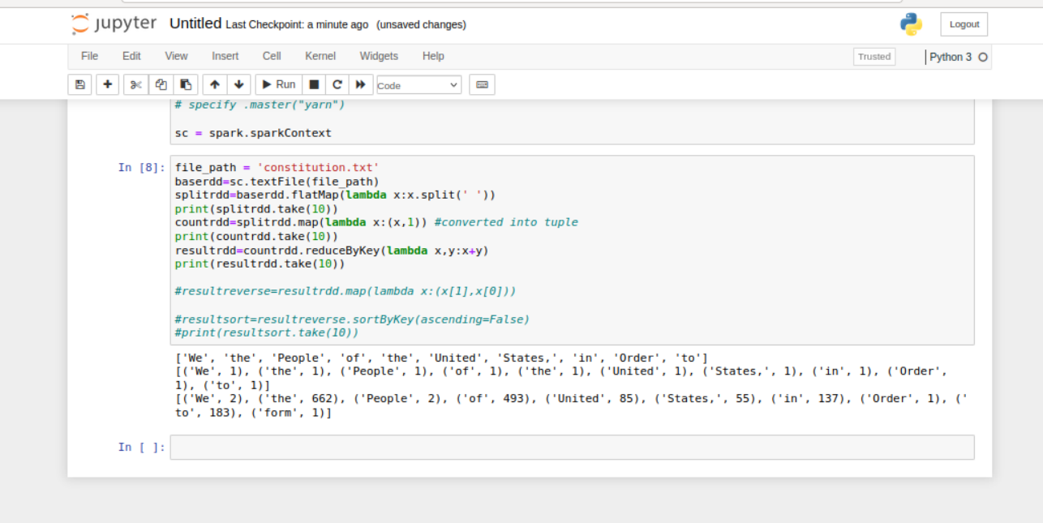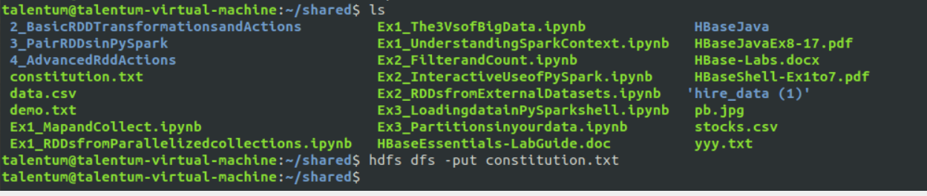

Secondway

One line code

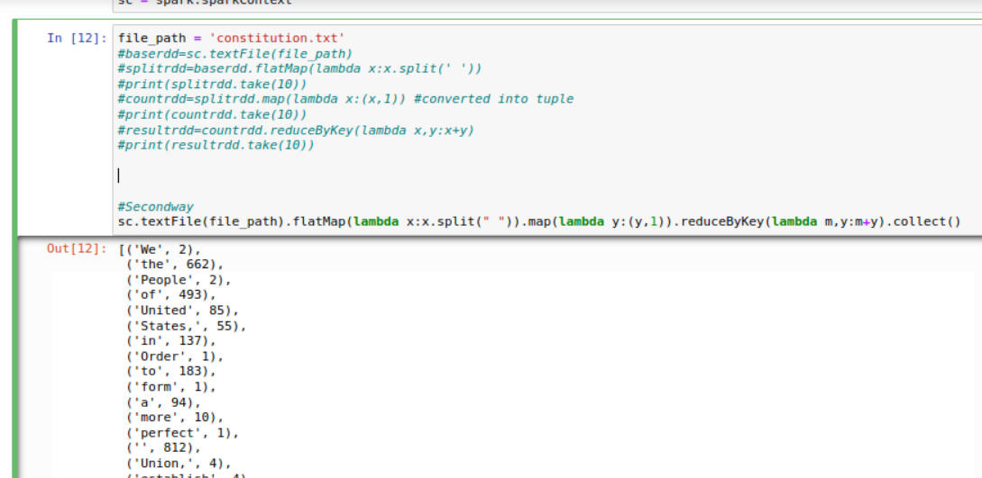

STANDALONE

Creating file for –unset

Creating .py file for count

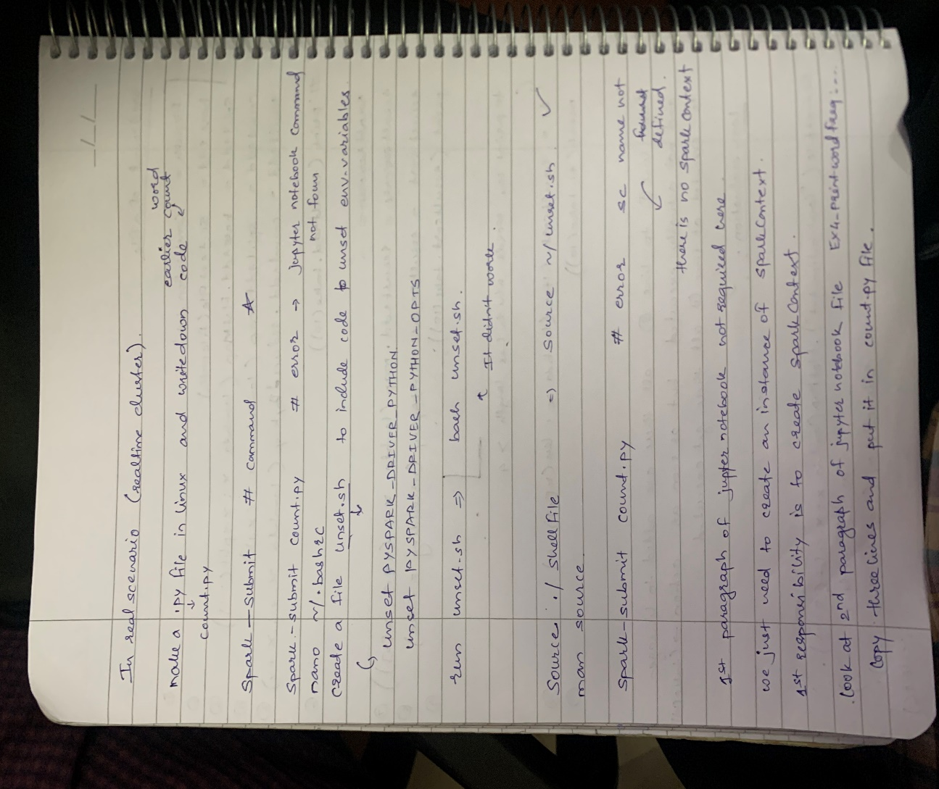

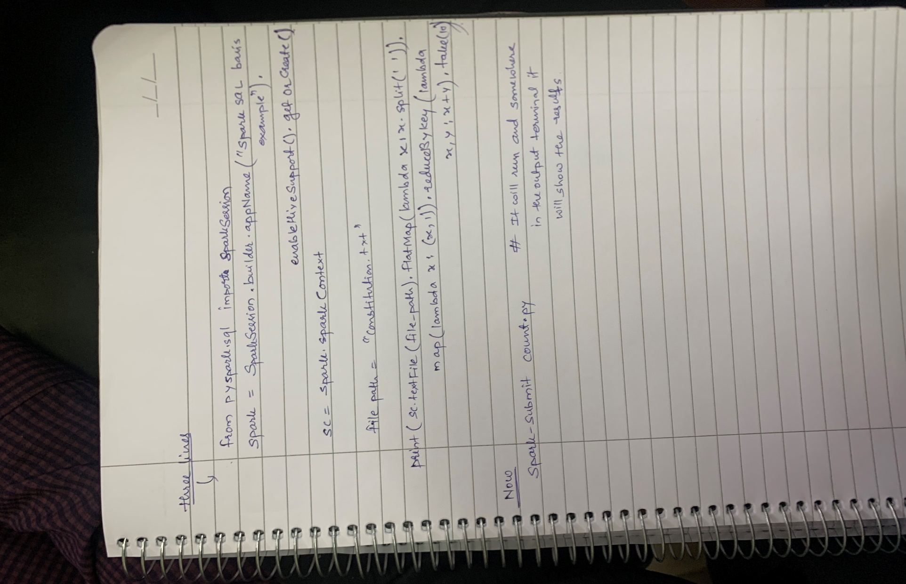

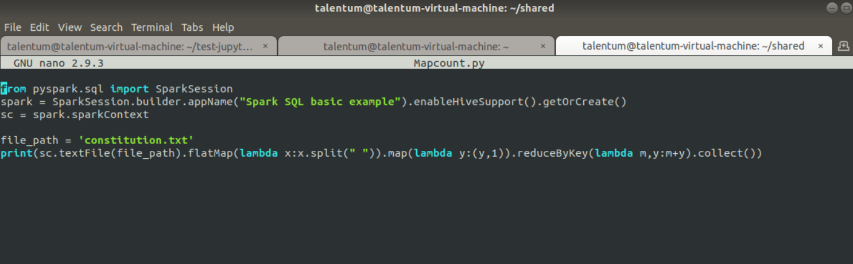

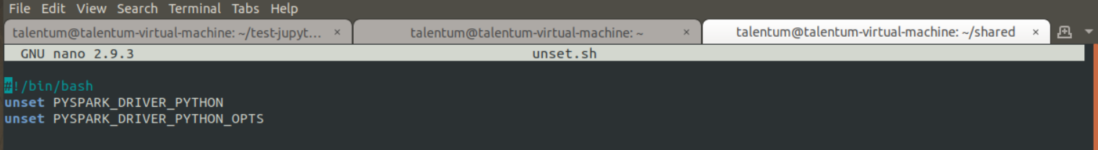

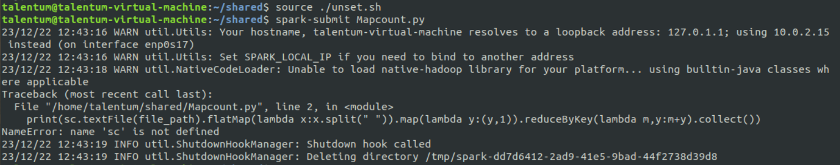

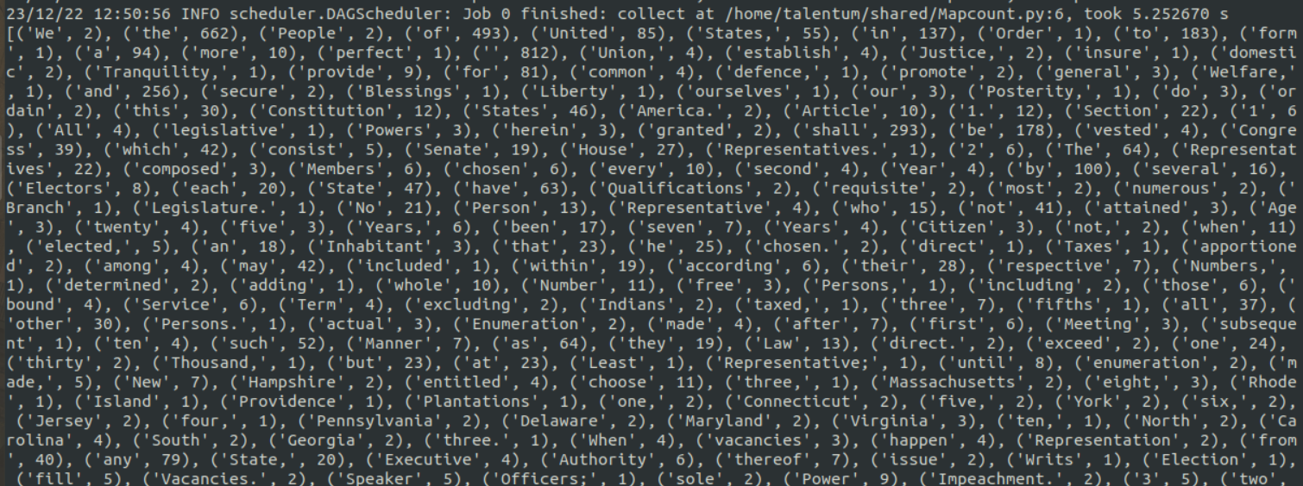

Now automate

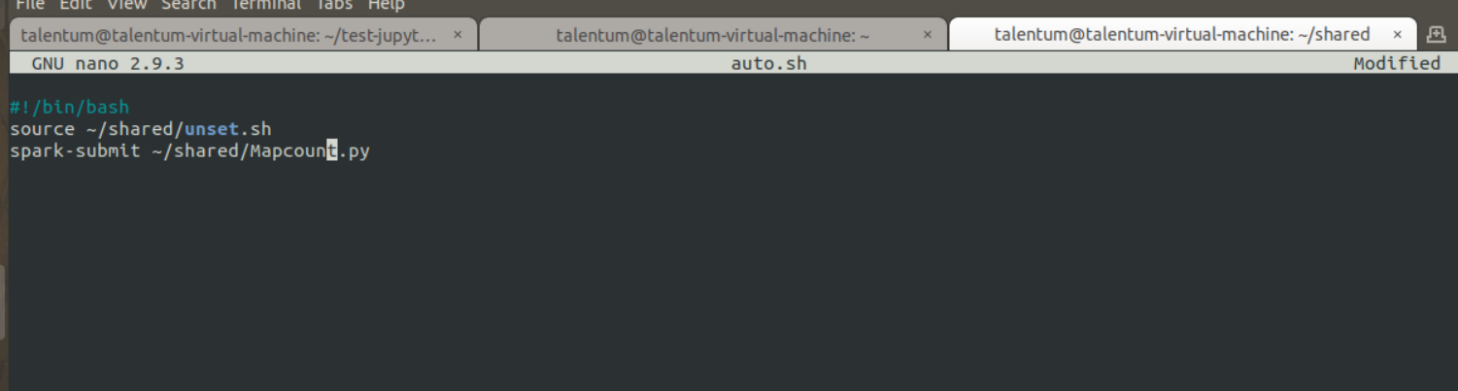

Automate

ShakesSpeare Count



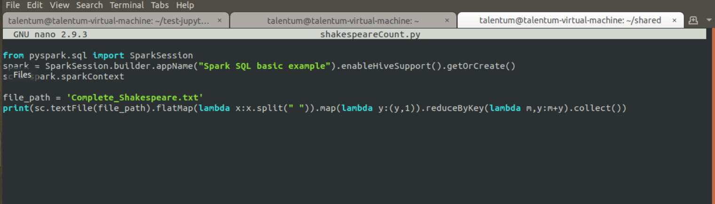

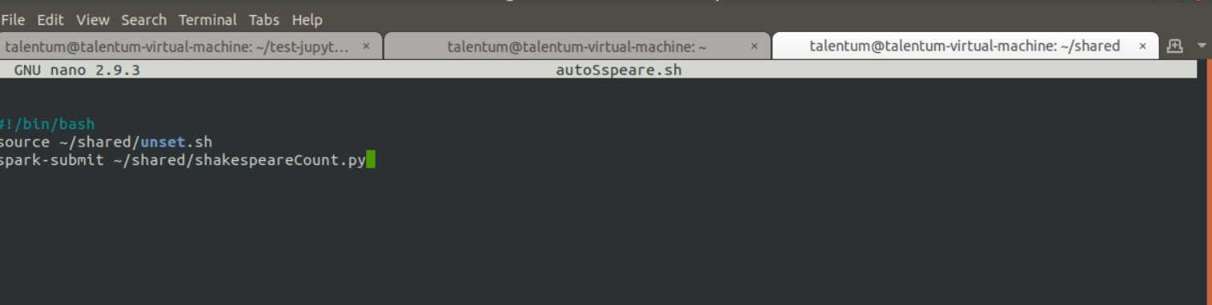



Output

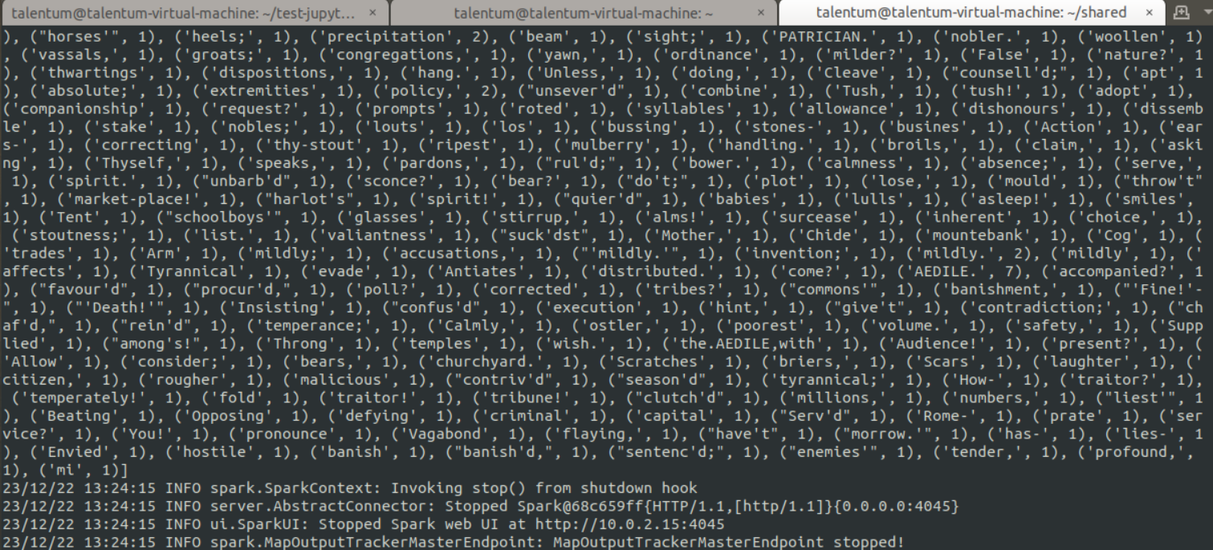

LAB4 :CREATE AND MANIPULATE PAIR RDDS (PYTHON)



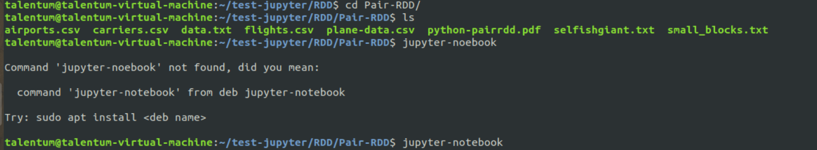

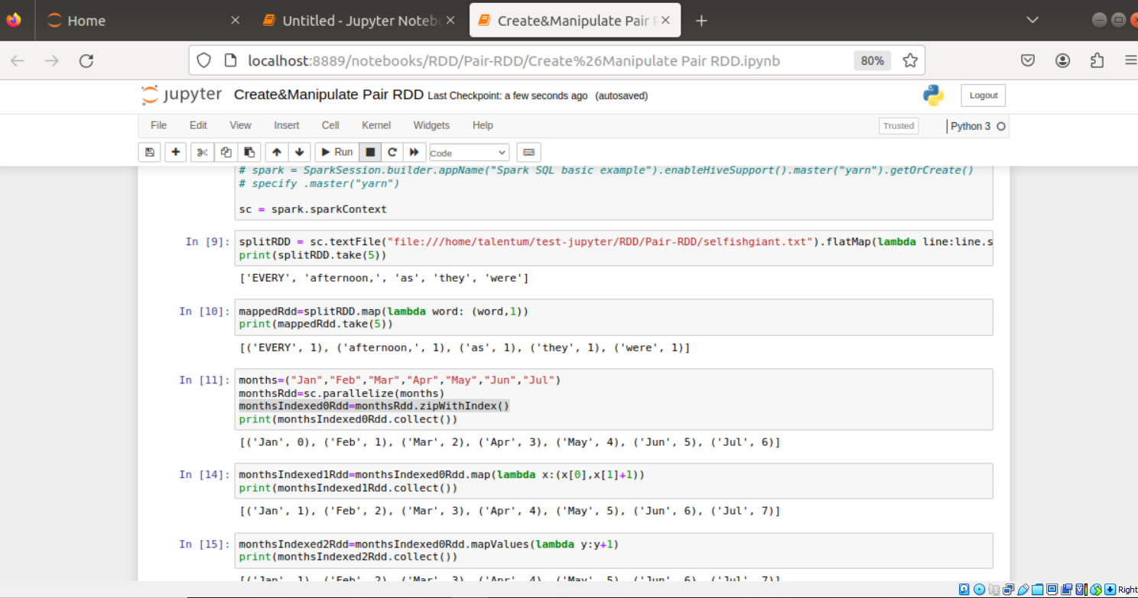

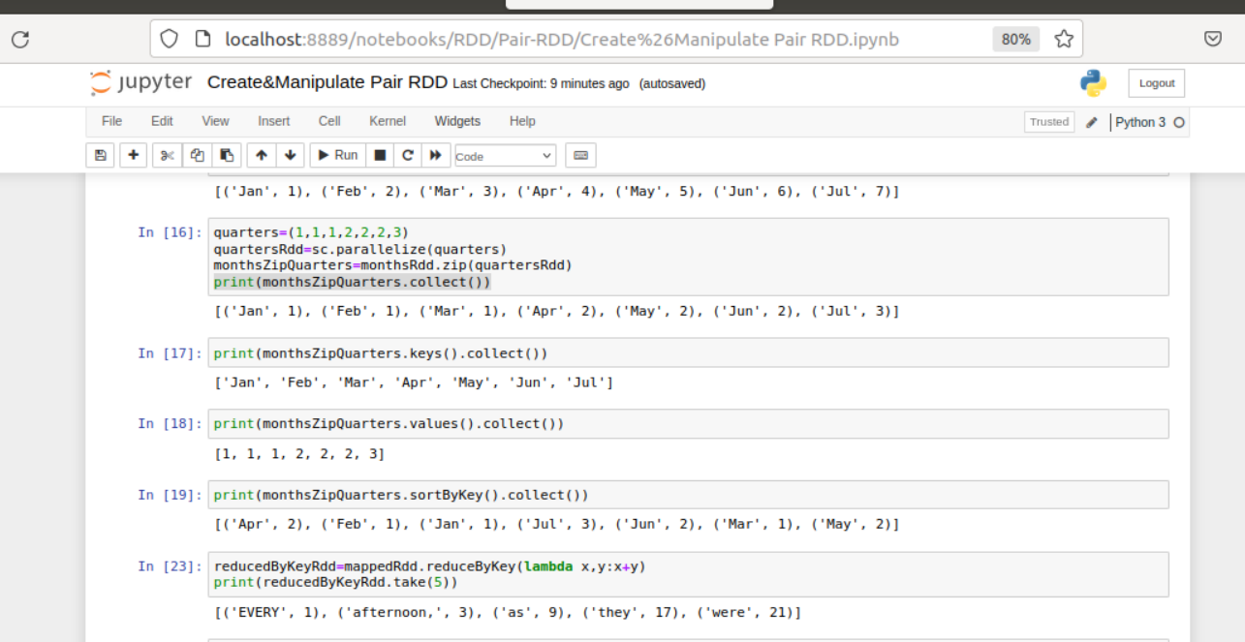

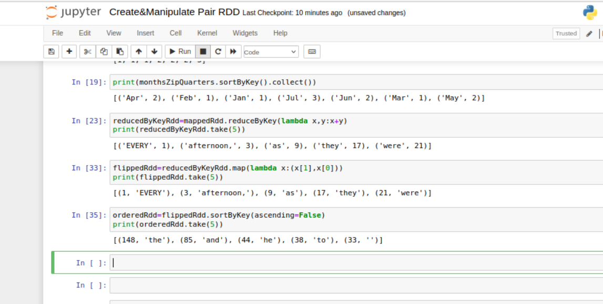

Challenge Labs

# Intialization

import os

import sys

os.environ["SPARK_HOME"] = "/home/talentum/spark"

os.environ["PYLIB"] = os.environ["SPARK_HOME"] + "/python/lib"

# In below two lines, use /usr/bin/python2.7 if you want to use Python 2

os.environ["PYSPARK_PYTHON"] = "/usr/bin/python3.6"

os.environ["PYSPARK_DRIVER_PYTHON"] = "/usr/bin/python3"

sys.path.insert(0, os.environ["PYLIB"] +"/py4j-0.10.7-src.zip")

sys.path.insert(0, os.environ["PYLIB"] +"/pyspark.zip")

# NOTE: Whichever package you want mention here.

# os.environ['PYSPARK_SUBMIT_ARGS'] = '--packages com.databricks:spark-xml_2.11:0.6.0 pyspark-shell'

# os.environ['PYSPARK_SUBMIT_ARGS'] = '--packages org.apache.spark:spark-avro_2.11:2.4.0 pyspark-shell'

os.environ['PYSPARK_SUBMIT_ARGS'] = '--packages com.databricks:spark-xml_2.11:0.6.0,org.apache.spark:spark-avro_2.11:2.4.3 pyspark-shell'

# os.environ['PYSPARK_SUBMIT_ARGS'] = '--packages com.databricks:spark-xml_2.11:0.6.0,org.apache.spark:spark-avro_2.11:2.4.0 pyspark-shell'

#Entrypoint 2.x

from pyspark.sql import SparkSession

spark = SparkSession.builder.appName("Spark SQL basic example").enableHiveSupport().getOrCreate()

# On yarn:

# spark = SparkSession.builder.appName("Spark SQL basic example").enableHiveSupport().master("yarn").getOrCreate()

# specify .master("yarn")

sc = spark.sparkContext

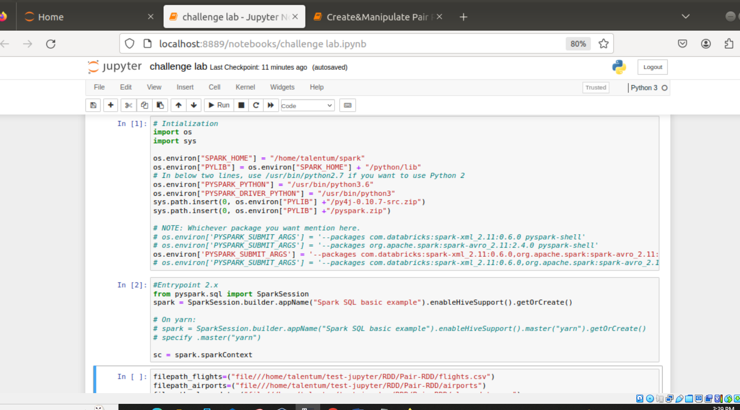

Incomplete

9] PySpark SQL & DataFrames

(M3->sm1)

1) Download RAR on STAGING_AREA

2) Extract the RAR

3) Put the *.ipynb files in UBUNTU_HOME/test-jupyter/P2/M3/sm1

4) Import the notes in Jupyter Notebook

5) Follow the instructions and give the solutions

* Code/Dataset

data/1_AbstractingDatawithDataFrames.rar

TimeLine = 15 Minutes

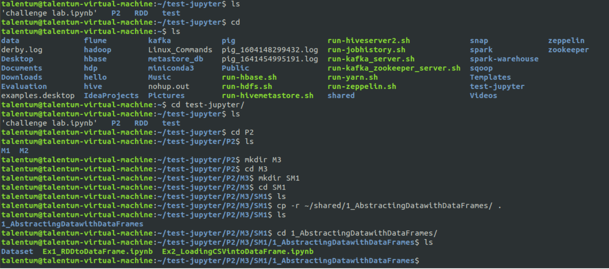

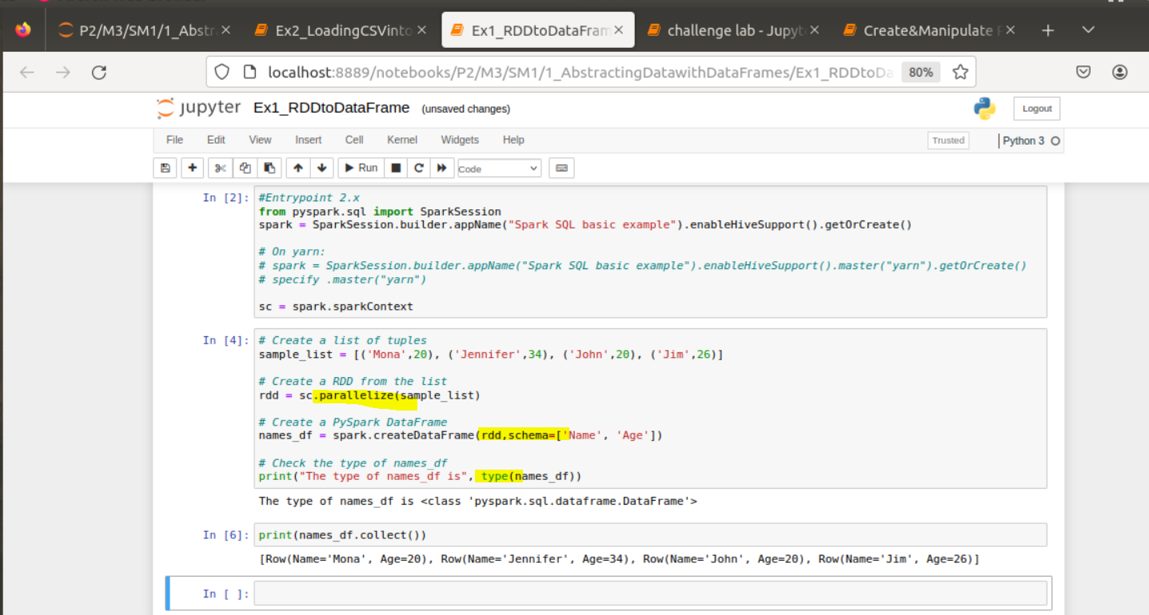

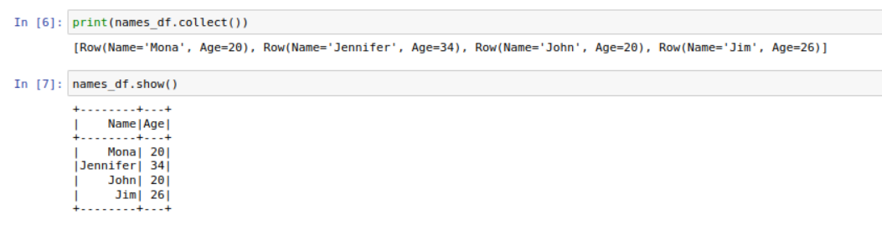

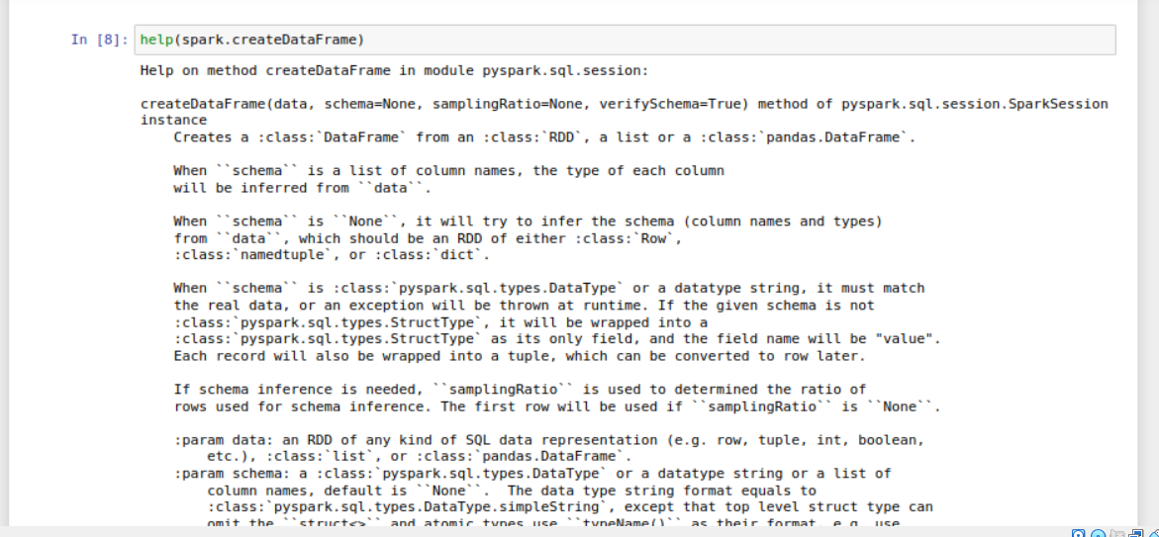

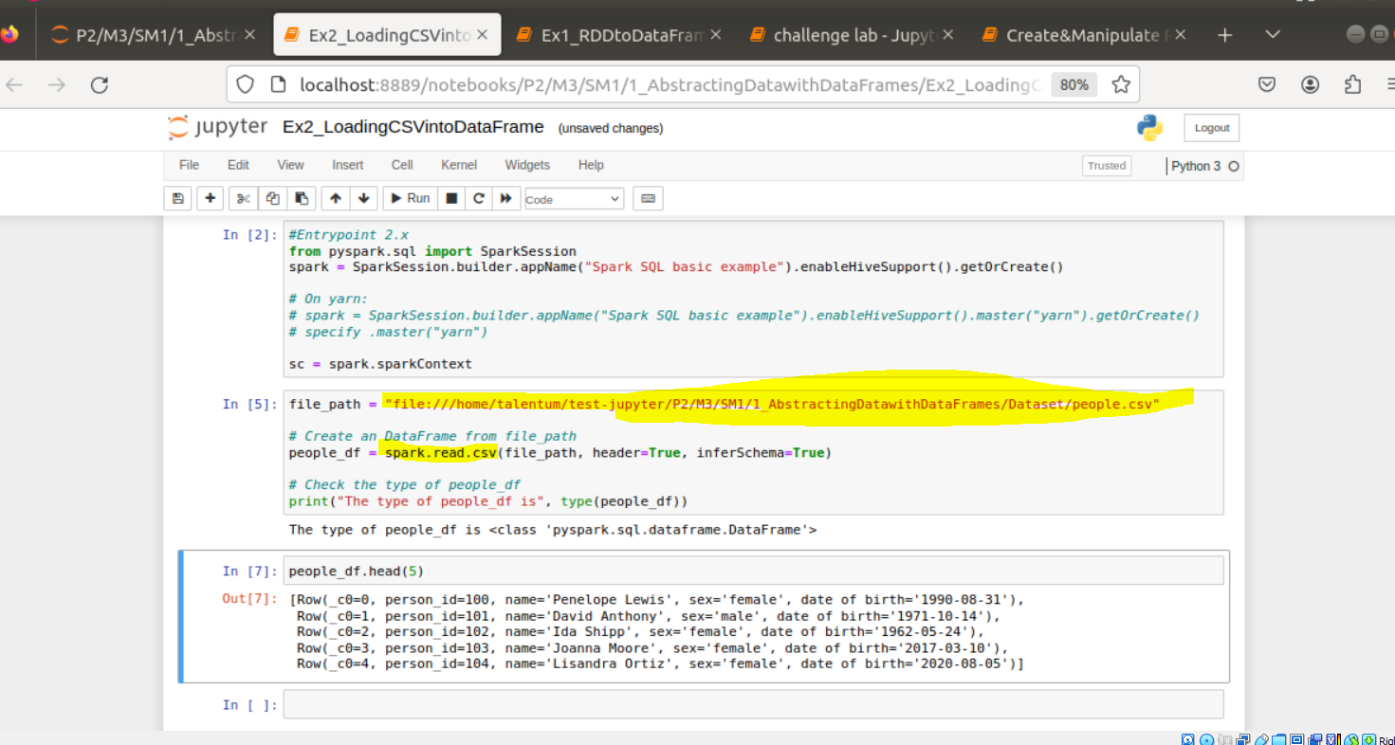

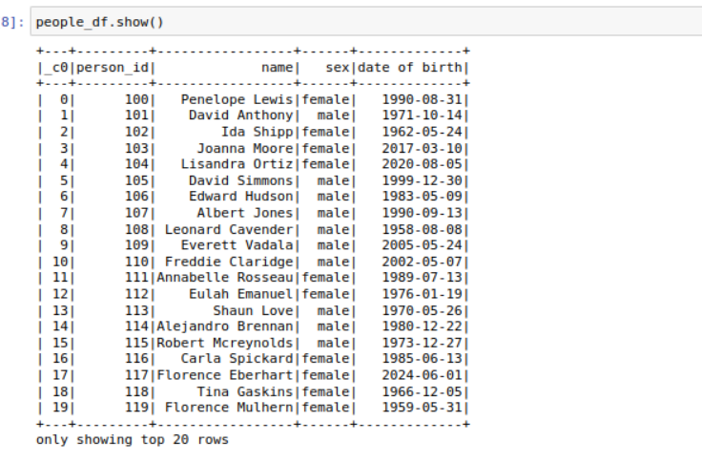

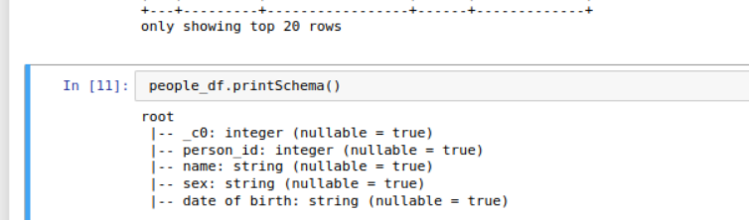

10] PySpark Sql and DataFrame

(M3->sm2)

1) Download RAR on STAGING_AREA

2) Extract the RAR

3) Put the *.ipynb files in UBUNTU_HOME/test-jupyter/P2/M3/sm2

4) Import the notes in Jupyter Notebook

5) Follow the instructions and give the solutions

* Code/Dataset

data/2_OperatingonDataFramesinPySpark.rar

TimeLine = 25 Minutes

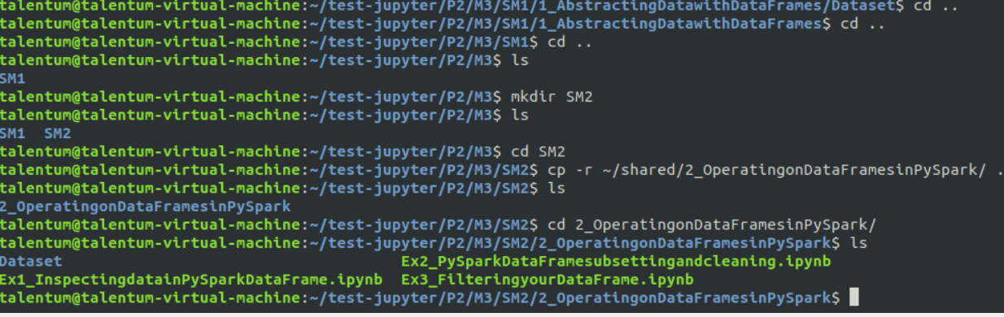

COPY BELOW PWD



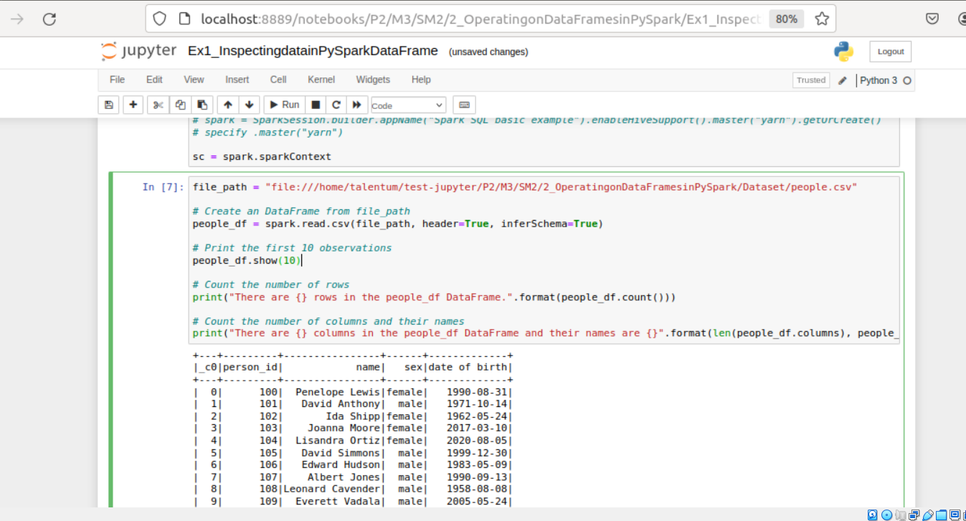

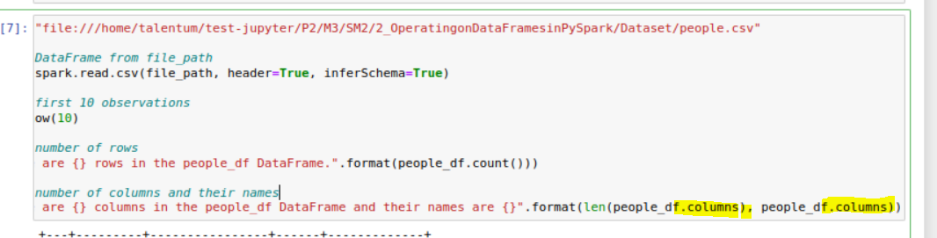

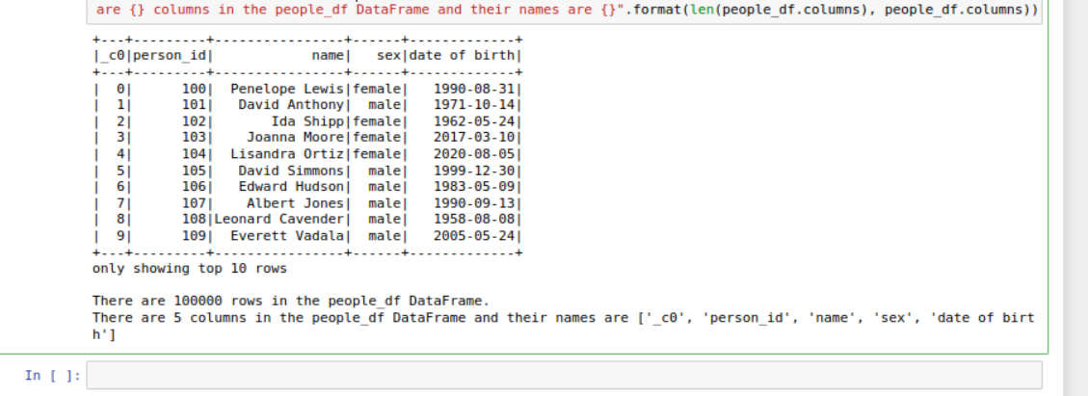

Ex2

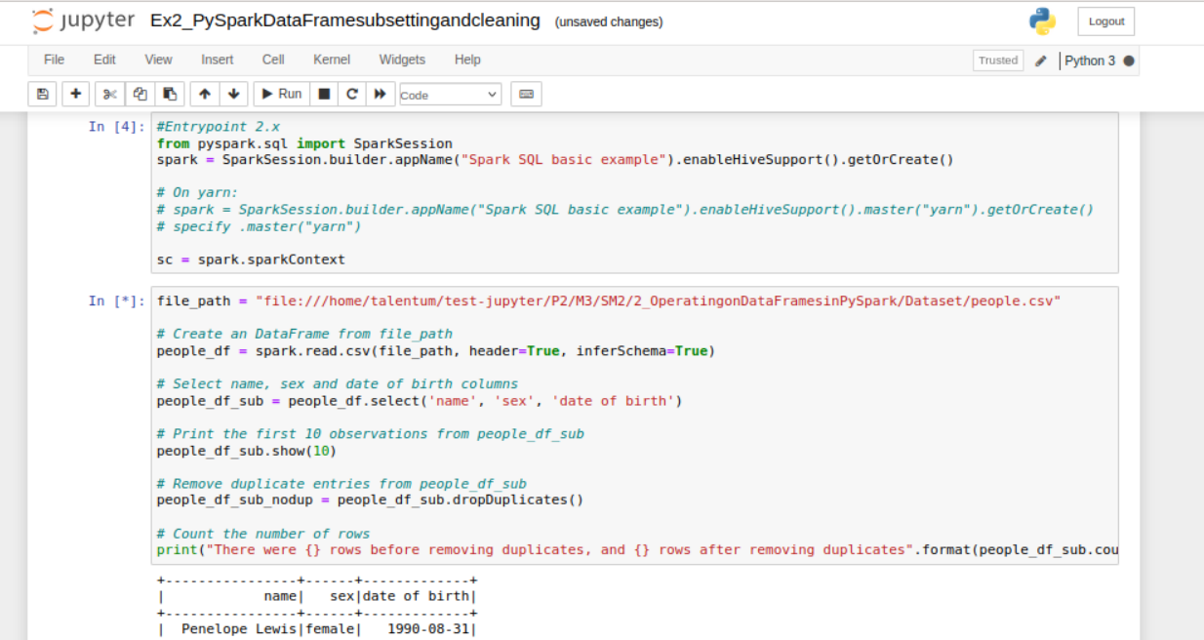

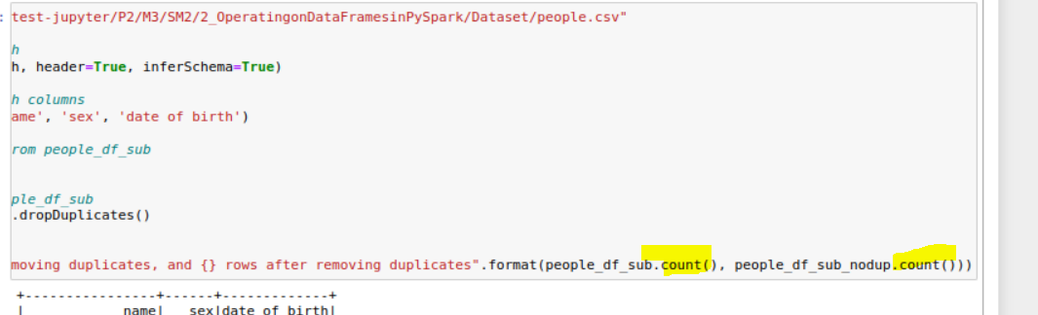

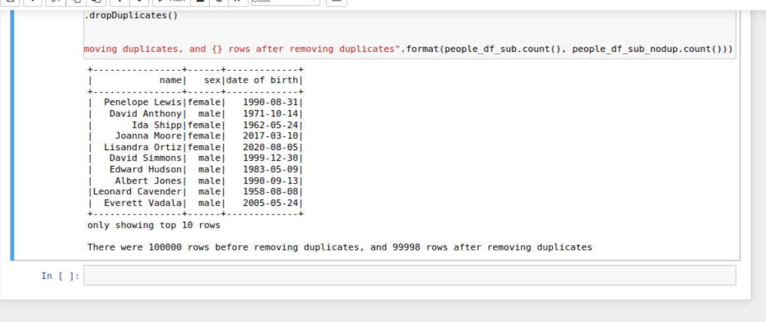

Ex3

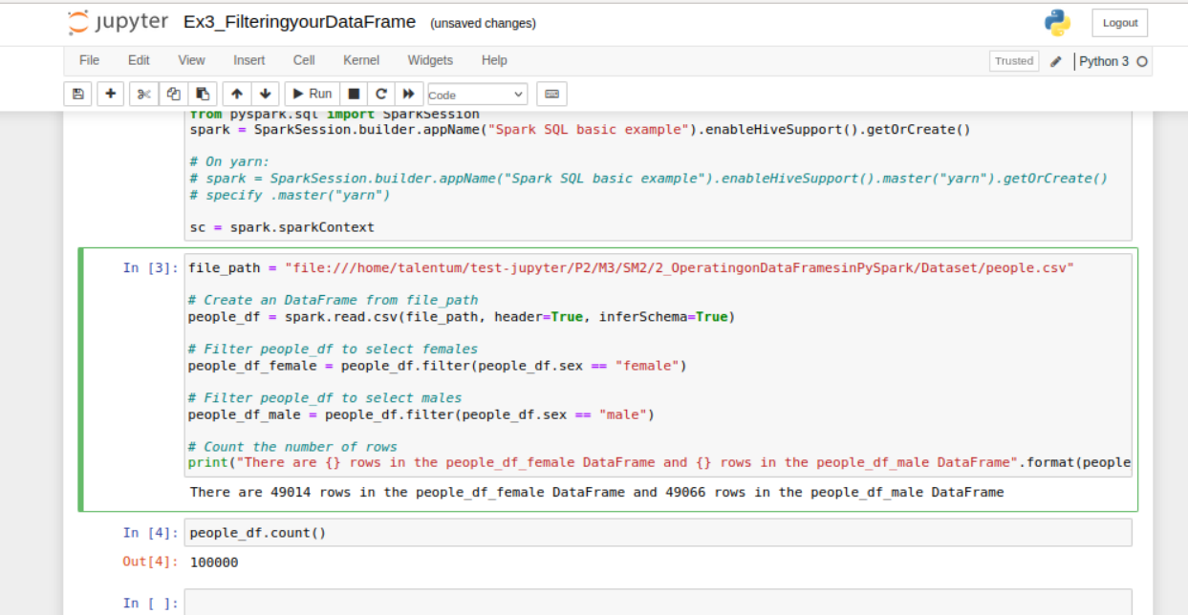

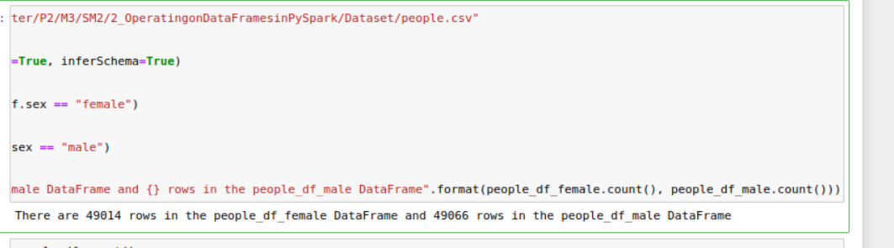

Show duplicates records

